**Discussion Question: 100 Things**

Using the ***100 Things Every Designer Should Know About People*** reading assignment, select two (2) of the "things" you read about, include the number and title of the "thing" (i.e., #36 Time is Relative)  and then do two embellishments, one embellishment and one visual example, or two visual examples.

1. **Embellish:** Tell us something that the reading did not tell us on that specific "thing" or embellish on what was presented. Be sure you are adding meaningful content to the conversation and not just making noise. Your addition can be a link to an article or you can write out your embellishment.
2. **Visual Example:** Provide us with a graphic example that is relevant to web design. This can be something you create or something you find. Again, be sure to add meaningful content to the conversation.

The first topic I decided to focus on is #15 Pattern Recognition Helps People Identify Letters in Different Fonts. Beyond letters, this same principle applies to numbers. Even when the exact number is shown in different fonts or when reading someone’s handwriting, we can still recognize it as the number. This also goes for other things like items, animals, and places. If you have seen a horse, you do not have to see them all to be able to recognize one when you see it. Similar to wanting to use more appealing fonts, we want to utilize images that appeal to our audience. Images should not be offensive or obscene in nature. Images should match the message, as should fonts. Imagine reading a news article that uses funky or funny fonts to deliver serious messages or headlines. Similar to how decorative fonts make reading take longer, confusing or unrelated images could cause viewers to be distracted in a bad way. This would be more fitting for a web-based or something similar.

I included a stick figure horse as a visual example. Even though a real-life horse looks much different than this image, the simple layout is enough for people to tell the animal type.



The second topic I decided to dive deeper into is #20 People Remember Only Four Items at Once. Our text mentions how phone numbers are separated to make remembering easier, but it goes much further. Credit and debit cards use this same format to make it easier to remember and read in general. Websites often add spaces or four separate boxes when entering a card number. Social security numbers, too.

This image shows how separating spaces is automatic when entering a card number. This makes entering your number much easier and fits the format that your card already uses.

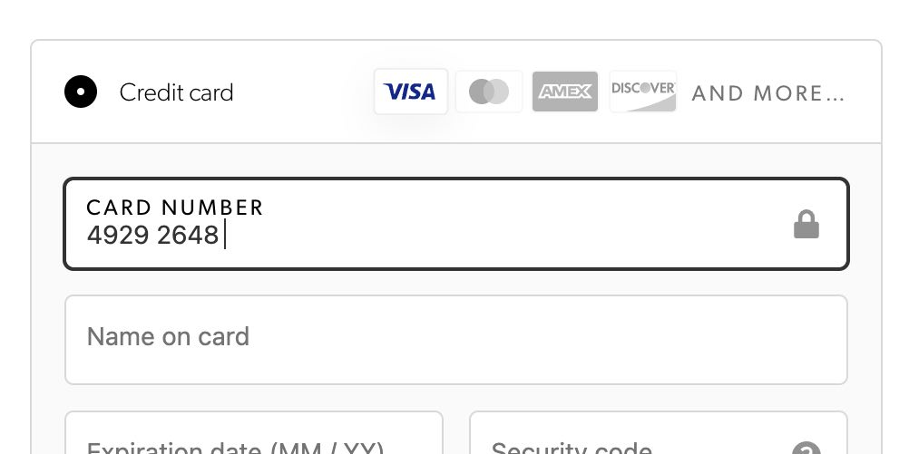

https://cdn.baymard.com/research/media_files/attachments/57440/original/research-media-file-cfc61d9974ca1ba5baebe279d8348e36.jpg

***Before you submit your thread, put your name in the subject line.***

**Assignment Requirements and Grading:**

1. An initial post of approximately 250 words is due by **Thursday, 11:59 p.m. CST**.
2. For the initial post to be considered substantive, it should be at least 250 words in length and fully cover the topics being presented. Single-sentence definitions or responses will not be awarded points.
3. Submit your post by clicking on the **Assignment Link** above, then **Create Thread**. You must create a thread in order to view your peers' posts. Tip: Create your post in a Word document and then copy and paste your work into the thread.
4. A minimum of three (3) responses, **to the original threads of other students**, of 100-200 words each are due by **Sunday, 11:59 p.m., CST**.
5. To view the rubric grading criteria, click on the following link: [Discussion Board Grading Rubric](https://content.bellevue.edu/cst/csd/rubricdbv3.pdf).

**(50 points)**